**Homework 1: Review of vector fields for meteorology.**

*Uses Feynman lectures:* [*Vectors*](https://feynmanlectures.caltech.edu/I_11.html)*,* [*Differential Calc of Vector Fields*](https://feynmanlectures.caltech.edu/II_02.html)*,* [*Vector Integral Calculus*](https://feynmanlectures.caltech.edu/II_03.html)

In meteorology, we often make use of Cartesian coordinates (x,y,z) for clarity, even though the Earth is round, when discussing weather patterns much smaller than the globe. Strictly speaking, this is a *local tangent plane* assumption, and is good enough for all our purposes this semester. Here we use (x,y) as pseudo-Cartesian distance (east,north *with* *units of meters*) from some reference point, and we use z as distance above mean sea level. Unit vectors along (x,y,z) axes are (ime t (*with units of seconds or days)* is relative to a convenient t=0 reference time.

Consider the horizontal velocity field

with

Combining these,

Or in the notation where <> indicates vector components,

>

Notice we could also write this as two different vector fields:

where one vector field is:

and the other is:

For convenience (no calculators needed, use brain!), A = 1 m/s (100 km)-1, S = 1m/s km-1, C = 1 day-1, and please consider only the domain since otherwise the values blow up without limit. As a crutch to see the pattern (*but use brain and units and Legend for care in your sketching!*), [this site](https://user.mendelu.cz/marik/EquationExplorer/vectorfield.html) gives a quick view.

>

1. Sketch a few vectors (taking care about their length, using the conversion factor that a 10m/s vector has length 100 km on the distance axes). Draw vectors along the x and y axes, and along the diagonals, by evaluating the formula above *at the surface at the initial time (for z=0 km, t=0 days)*.

for A = 1 m/s (100 km)-1, S = 1m/s km-1, C = 1 day-1

Once you see the pattern, lightly sketch a few streamlines (parallel to the vectors everywhere).

>

2. Repeat the exercise for z = 10 km, t = 0 days. Describe the flow in a sentence or two of words. Yes, words for flow are a bit challenging, but this is the point: to learn some. You may wish to use geographical directions (north, south, east west). Where are the winds *southwesterly? (from* the southwest)? Where are they *eastward?* (*toward* the east)

>

3. Repeat the exercise for z = 10 km, t = 1 day. Are there any *easterly* (that is, *westward)* winds?

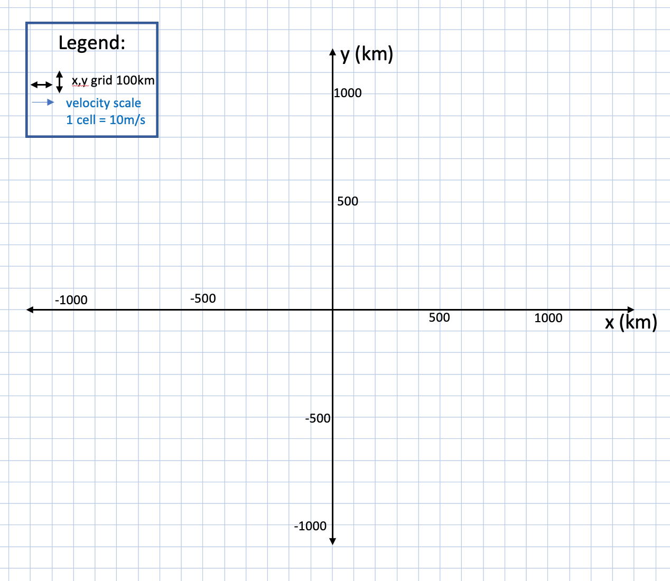

>

4. Consider this difference of vectors *at two specific points*:

Because all the function arguments in parentheses (Not Components <>!) are definite locations, these are *individual velocity vectors at that location,* not vector fields. *They have magnitude and direction but not position: you can move them around in order to add and subtract them.*

a. **Make a clearsketch of these two vectors and their difference,** showing your graphical subtraction work by your relative positioning of the vectors, labeling, etc. See the caution of Fig. 11-7 [here](https://feynmanlectures.caltech.edu/I_11.html) about how individual vectors are repositioned for this purpose. Remember, you can think of subtraction as *adding the negative of the second vector.* I find vector addition (tip to tail) much more intuitive, like a journey, so I use this negation trick constantly.

**Notice that the axes of this sketch are u and v components, not x and y (position):**

>

b. Compute the value (with units!) of from the mathematical formula (function) for . What is the name for this quantity? Hint: I chose the coefficient letters carefully.

c. What is the inner or dot product ? Explain the geometric meaning of this quantity as seen on your diagram (that is, how can you tell its sign just by glancing at the vectors? see section 11-7 [here](https://feynmanlectures.caltech.edu/I_11.html)). Also, calculate its value mathematically. Does the sign agree with your graphical reasoning? Discuss (that is, show me your knowledge clearly please).

d. What direction is the outer or cross product product ? Explain how you can tell its direction (up or down) just by glancing at the vectors. Cross product formulas and discussion about the "right hand rule" are [here](https://www.feynmanlectures.caltech.edu/I_20.html#mjx-eqn-EqI209), or easily web-searched, or ask if this is unfamiliar.

>

5. We often use the dot product formula in a straightforward way, but with a special kind of pseudo "vector field": a *vector* ***operator****,* denoted by an upside-down triangle called "del". This vector Del notation is "extremely amusing and ingenious" as discussed in section 2-4 [here](https://feynmanlectures.caltech.edu/II_02.html). Study it well, this is close to the heart of our material.

First, you should know what a derivative "operator" is. If you understand that df/dt = d/dt(f) is the slope of the curve f(t), then just consider d/dt or d/dt() as the *operator* that takes the derivative (or "measures the slope") of whatever function of time is put to its right. But be careful! Whatever is put to the left of d/dt is simply multiplied, as in regular algebra. For example, d/dt(5) = 0, but 5d/dt or 5d/dt() is five times the derivative of whatever function is put to the right of d/dt or in the parentheses.

Del is written as (the symbol is called a "nabla"). Sometimes it has subscripts, to emphasize whether it is derivative in 3D space, or a 2D derivative along some surface, like a horizontal surface of constant z, or a constant-p surface.

When Del is applied to a ***scalar field***, it creates a vector field called the ***gradient****.* Please learn this word well, for instance from diagram 2-1 [here](https://feynmanlectures.caltech.edu/II_02.html).

When Del is combined with vector fields in various ways, it has other names. When Del is dotted into a vector field, it measures the ***vergence or divergence*** *(meaning: arrows-pointing-apart)*of that field. When divergence is negative, or if we are speaking of the negative of vergence, we use the word ***convergence.*** (arrows-pointing-together).

a. Use the dot product definition to derive the mathematical form of the divergence of our vector field, from the first page. To do this, write down and write down . Then, just naively apply the dot product formula, like you would for any two vectors. Finally, in a separate step, apply the partial derivative operations in that formula, to evaluate the result.

b. Does the result make sense, in terms of the image of arrows "verging” together (con-) or apart (di-) in the sketches? Put it in your own words.

>

c. When Del is crossed into a vector field, it measures the ***curl*** *(arrows-going-around)*of that field. Derive for all times, altitudes, and places by doing this mathematical operation. Finally, in a separate step, apply the partial derivative operations in that formula, to evaluate the result.

>

6. In this part, you will compute a *line integral* of the *perimeter-normal component* (that is, the inflow or outflow component) of around the square box centered on the origin. **Sketch this box on your diagram from problem 2. for reference.**

a. Mathematically, by adding up 4 terms for the 4 sides, construct the line integral:

where is the distance increment ds (dx or dy for the edges of a square box), times the unit vector pointing directly ***out of*** the box. That is, on the east side = , on the north side it is , on the west side it is dy, and so on. Notice that this dot product with the unit vector extracts just one component of for each box edge, so it's not too ugly or gory.

b. What are the units of this integral?

c. Read the essential sense of Gauss's theorem in section 3-3 [here](https://feynmanlectures.caltech.edu/II_03.html). How does your integral relate to the result from part 5. ? Do the values agree and make sense? Explain.

>

7. In this part, compute the other line integral*,* of the *along-perimeter component* for the same box. The convention is to integrate in the ANTI-CLOCKWISE direction.

a. Mathematically, by adding up 4 terms for the 4 sides, construct the line integral:

where is the distance increment ds (dx or dy, for a square box), times the unit vector pointing DIRECTLY ALONG THE PERIMETER of the box. That is, up the east side it is , on the north side it is -, down the west side it is - dy, and so on.

b. What are the units of this integral?

c. Read the essential sense of the Circulation theorem (Stokes's theorem) in section 3-5 and 3-6 [here](https://feynmanlectures.caltech.edu/II_03.html). Do the values and sign of your integral make sense for the swirl of your arrows in your sketch of Part 2, and the curl you calculated in problem 5d. above? Explain.